命名約定

Naming conventions

電子元件命名標準，以實現和改善全球合作

Standards for naming of electronic documents and components to enable and improve global cooperation

# 

# 文件修訂紀錄 About

|  |  |  |  |
| --- | --- | --- | --- |
| 版本號碼 | 異動日期 | 異動者 | 異動項目 |
| Version no. | Change Date | Author or Contributor | Remark |
| V1.0 | 20190917 | Eddy_A ([eddy_a@talfin.ai](mailto:eddy_a@talfin.ai)) | 初版  1st version |
| V1.1 | 20191127 | Eddy_A ([eddy_a@talfin.ai](mailto:eddy_a@talfin.ai)) | 完成英文版  Completed English version |
| V1.2 | 20200116 | Queenie ([queenie_chang@talfin.ai](mailto:queenie_chang@talfin.ai) ) | 校對修正  Proof-reading and revision |

此文件提供命名及語言規範與準則，旨在提升組織合作效率。

This document offers naming and language conventions, guidelines, and tips. The goal is to create an efficient method of cooperation for everyone in our company.

第一章解釋一般性原則和命名公式，並提供範例說明。

In the first chapter we explain the general convention and the naming formula and give examples.

作為一家科技公司，我們擁有許多可以自動翻譯的工具，將於第二章詳加介紹。

As a technology company we have a lot of tools at our disposal that can automate translation. The tools that we’ve selected are explained in chapter 2.

第三章為不同程式語言之編碼約定和準則，亦提供文件連結，進一步說明編碼方針。

In the third chapter we talk about conventions and guidelines for coding in various programming languages and offer links to documentation with more detailed coding guidelines.

# 

# 目錄 TOC

**文件修訂紀錄 About** **2**

**目錄 TOC** **3**

**一、通用命名原則 General naming convention** **4**

中文 vs 英文 Chinese vs English 4

自動化 vs 專業翻譯 Automated vs Professional translation 4

**二、命名準則與約定 Naming guidelines and conventions** **5**

Skype暱稱命名原則 Skype names policy 6

其他準則 Other naming guidelines 6

**三、技術輔助 Technology aids** **7**

電子郵件 Email: GMail 8

網站 Websites: Chrome 插件 - Google 翻譯 Chrome plugin Google Translate 8

表格中的自動標題和數據翻譯：Google表格（或MS Excel） Automated headers and data translation in sheets: Google Sheets (or MS Excel) 9

文檔中的自動內容翻譯：Google Docs（或MS Word） Automated content translation in documents: Google Docs (or MS Word) 9

**四、編碼準則 Coding guidelines** **10**

PHP 10

PYTHON 10

C# 10

# 

# 一、通用命名原則 General naming convention

## 中文 vs 英文 Chinese vs English

命名原則皆包含台灣官方語言—繁體中文，以及國際商務語言—美式英文。以下簡稱繁體中文為[中文]

，美式英文為[英文]。

These naming conventions combine the official language of Taiwan; Chinese (Traditional) with the international business language, American English. In this document we will refer to Chinese (traditional) as [Chinese] and American English as [English].

## 自動化 vs 專業翻譯 Automated vs Professional translation

Google翻譯(<https://translate.google.com>)或微軟Bing(<https://www.bing.com/translator>)等自動翻譯皆足以滿足大部分的**內部需求**，雖然它們有時會給出奇怪或令人困惑的結果，但與本文檔中的其他準則結合使用時，它們在99％的情況下能產生可理解的結果。若有其他需求，歡迎聯繫 [helpmetranslate@talfin.ai](mailto:helpmetranslate@talfin.ai)。

For most **internal uses** the automated translation with services such as Google Translate (<https://translate.google.com>) or Microsoft Bing (<https://www.bing.com/translator>) are sufficient. They sometimes give weird or confusing results. But when combined with the other guidelines in this document, they should produce understandable results in 99% of the cases. In the other cases, you can always contact [helpmetranslate@talfin.ai](mailto:helpmetranslate@talfin.ai).

對於所有外部使用，也就是所有致公司外部或非公司員工之文件或溝通內容，或需要一份精準無誤的翻譯文件等，強烈建議由人工進行專業翻譯。此等需求請聯繫 [helpmetranslate@talfin.ai](mailto:helpmetranslate@talfin.ai) 或特約翻譯社(副本寄送給Eddy和Queenie)：

For all external uses, which means any document or communication that leaves the company or can be accessed by non-employees, or when there is a specific need for an error-free translation, professional translation by humans is highly recommended. For professional translation, please contact [helpmetranslate@talfin.ai](mailto:helpmetranslate@talfin.ai) or work with our translation agency (CC Eddy and Queenie):

HONG YAN Translation Co., Ltd.

台北市106羅斯福路三段281號3樓

TEL: 02-23657723

FAX: 02-23672037

E-mail: [hyt8011@ms13.hinet.net](mailto:hyt8011@ms13.hinet.net); [hyt8011@seed.net.tw](mailto:hyt8011@seed.net.tw)

SKYPE: hyt80118012

line: hytranslation

網址：<http://www.hong-yan.com.tw/>

# 

# 二、命名準則與約定 Naming guidelines and conventions

請遵循以下公式命名所有文件夾、子文件夾、文件與任務名稱(Trello, YouTrack, Asana, Google Keep,..)。

For the naming of all folders, subfolders, documents, and tasks (Trello, YouTrack, Asana, Google Keep ..), please use this formula:

**名稱 = 中文名稱 + _ + 英文名稱(額外信息)**

**Name = Chinese name + _ + English name(Extra info)**

如欲備註此文件尚未完稿(草稿)，或加註版本號、解析度等訊息，請使用英文(半型)括弧，括弧內文字中英文皆可。

For similar documents, you can add extra info between English brackets in English or Chinese as required to differentiate from other documents (version number, quality) or to make it clear that this is not the final version (Draft) or you (Eddy_A) are still working on this document.

範例1：此文件名稱為[命名約定_Naming conventions (Bilingual)] (= 命名約定 + _ + Naming conventions + (Bilingual))

Example 1: This document is named [命名約定_Naming conventions (Bilingual)] (= 命名約定 + _ + Naming conventions + (Bilingual))

範例2：此文件儲存於Google雲端硬碟資料夾：

Example 2: This document is saved in the Google Drive folder:

範例3：人才招募部使用Trello管理任務與待辦事項，圖示如下：

Example 3: TRDP works with Trello for management of tasks and todos which looks like this:

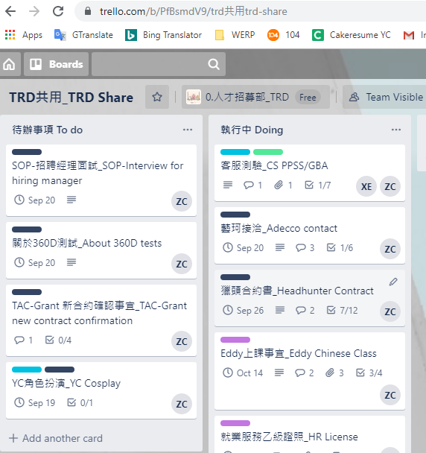

範例4：此文件備註版本號/解析度/草稿[命名約定_Naming conventions(extra info)]

Example 4: This document marked version number/quality/draft [命名約定_Naming conventions(extra info)]

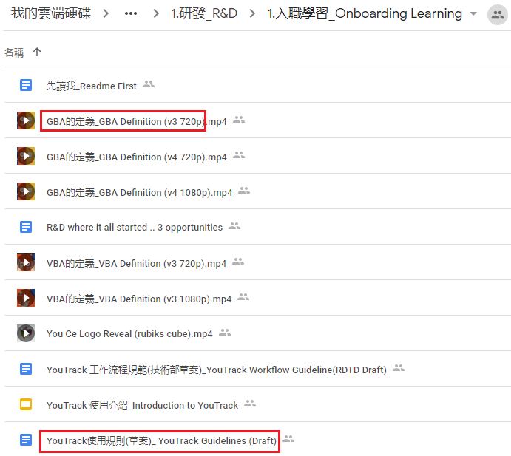

## Skype暱稱命名原則 Skype names policy

為能更方便於Skype搜尋並@同事，Skype暱稱命名原則調整如下：

There is a different naming policy for Skype names to make it easier to search and @mention colleagues:

1. Skype暱稱為[email暱稱-中文部門名稱#分機號] (範例：Eddy_A-總經理研發處#1100)。

1. Your Skype names should be [EmailName-ChineseDepartmentName#PhoneExtension]. (eg Eddy_A-總經理研發處#1100).

2. 若無分機號，直接省略即可(範例：Eddy_A-總經理研發處)。

2. If you don't use a phone, you can leave out the last part. (eg Eddy_A-總經理研發處)

## Skype群組命名原則 Skype group name policy

為方便搜尋管理，Skype群組命名原則如下：

The naming policy for Skype group name is as follows:

中文名稱+(空格)+英文名稱(範例：研發技術部 RDSD)

Chinese name + (space) + English name (eg 研發技術部 RDSD)

## 其他準則 Other naming guidelines

1. Tableau標頭亦可使用預設之命名原則[中文單詞_英文單詞]

For Tableau headers we also use the default naming convention 中文單詞_English Name

1. 翻譯Excel或Google試算表分頁時，請遵循命名原則。翻譯標頭時，請在第二行或第二列添加每個標題的翻譯內容。欲了解如何自動翻譯標頭，請見下方Google試算表翻譯原則。

For the naming of tabs in Excel or Google Sheets, please follow the default convention. For headers, please add a second row or column with the translation of each header. See Google Sheets tip below to automatically translate all headers.

1. 文件內容無需翻譯，若需同時滿足中、英文讀者，文件可以中文與英文分別製作。

There is no need to translate the content of documents. When you have a bilingual audience, you can decide to create 2 versions of the document, 1 Chinese, and 1 English.

# 

# 三、技術輔助 Technology aids

## 電子郵件 Email: GMail

收到由其他語言撰寫的電子郵件時，大多會於郵件上方(1)出現一條消息。當您點擊時它會進行翻譯，您也可用它切換回原始語言。

When you receive an email in a different language, there will most likely be a message (1) on top of the email that translates the email when you click on it. You can also use it to switch back to the original language.

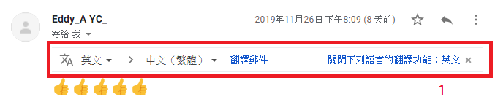

若信件中未出現此選項，請點選右邊的3小點(2)並選擇[翻譯郵件]。

If you don’t have this option on top of the email, click on the 3 dots (2) and choose [Translate this message] from the list.

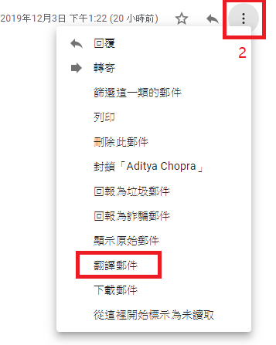

## 網站 Websites: Chrome 插件 - Google 翻譯 Chrome plugin Google Translate

若您常瀏覽外國網站，可至<https://chrome.google.com/webstore/detail/google-translate/aapbdbdomjkkjkaonfhkkikfgjllcleb?hl=zh-TW> 新增此擴充功能，安裝後瀏覽器右上方會出現藍色翻譯圖標。

If you often read websites in different languages, go to <https://chrome.google.com/webstore/detail/google-translate/aapbdbdomjkkjkaonfhkkikfgjllcleb?hl=zh-TW> to install the Google Translate extension for Google Chrome. This will add a blue translate icon to the top right of your browser.

右鍵點擊圖標(1)，然後選擇[選項]進行設置。

左鍵點擊圖標(2)，然後選擇[翻譯這個網頁]，針對目前瀏覽的網頁進行翻譯。

此時網頁上方會出現一個顯示列，讓使用者任意切換語言。

Right-click the icon (1) and choose options to set the default language and behavior.

Left-click the icon (2) and choose [Translate this page] to translate the webpage you’re currently viewing. This will also add a bar on top of the webpage where you can switch between languages.

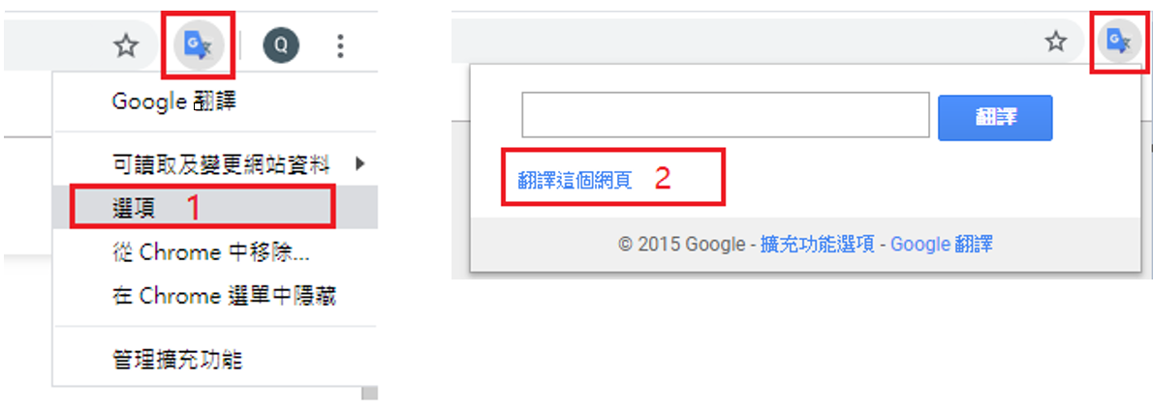

## 表格中的自動標題和數據翻譯：Google表格（或MS Excel） Automated headers and data translation in sheets: Google Sheets (or MS Excel)

Google試算表有個非常好用的公式 =GOOGLETRANSLATE，能快速翻譯數個儲存格、行、列或整個工作表，詳情請至<https://support.google.com/docs/answer/3093331?hl=zh-Hant>。

Google Sheets has a formula =GOOGLETRANSLATE that is very useful to quickly translate multiple cells, rows, columns, or entire tabs of data. For more information check out <https://support.google.com/docs/answer/3093331?hl=zh-Hant>

若您偏好使用微軟Excel製作試算表，但要翻譯的字段很多，可參考以下作法：

1. 儲存Excel表格並上傳至Google雲端硬碟。
2. 右鍵點擊文件並選擇[以Google試算表開啟]。
3. 按上方步驟進行翻譯。
4. 於Google試算表中選擇檔案 > 下載 > Microsoft Excel。

If you prefer to use Microsoft Excel for spreadsheets but you have a lot of fields to translate, you can use this workaround:

1. Save your Excel file and upload it to Google Drive.
2. Right-click the file and choose [Open with Google Sheets].
3. Follow the procedure above to translate.
4. In Google Sheets choose File > Download as > Microsoft Excel.

## 文檔中的自動內容翻譯：Google Docs（或MS Word） Automated content translation in documents: Google Docs (or MS Word)

Google文件有個很方便的功能，能立即翻譯整份文件，詳情請至 <https://support.google.com/docs/answer/187189?hl=zh-Hant>。

Google Docs offers a feature that is very useful to quickly translate an entire document. For more information check out <https://support.google.com/docs/answer/187189?hl=zh-Hant>

若您偏好使用微軟Word製作文件，但有許多資料需做翻譯，可參考以下作法：

1. 儲存Word文件並上傳至Google雲端硬碟。
2. 右鍵點擊文件，然後選擇[以Google文件開啟]。
3. 按上方步驟進行翻譯。
4. 於Google文件中選擇檔案 > 下載 > Microsoft Word。

If you prefer to use Microsoft Word for documents but you have a lot of data to translate, you can use this workaround:

1. Save your Word file and upload it to Google Drive.
2. Right-click the file and choose [Open with Google Docs]
3. Follow the procedure above to translate.
4. In Google Docs choose File > Download as > Microsoft Word.

# 四、編碼準則 Coding guidelines

對編碼人員而言，使用相同的命名與註解原則是非常重要的，以下連結按程式語言或技術提供相關規範。

For coders it is very important to use the same guidelines for naming and commenting. Below some links to guidelines and tips per programming language or technology.

## PHP <https://docs.google.com/document/d/1z5dYuZLweqHlog5ObgxUgJluD3qE-fv49m_bmlpJVx0/edit>

## PYTHON [https://docs.google.com/document/d/1q7OEFe9OTOavlGzmuXU2V36geOVZuNZWGFI6wRZlwiw/edit](https://docs.google.com/document/d/1q7OEFe9OTOavlGzmuXU2V36geOVZuNZWGFI6wRZlwiw/edit?usp=sharing)

## C#

<https://docs.google.com/document/d/1y0qFLIt9M0ahXO8n7cXfE7JOKHbMtvWwhuj6DVowcfM/edit>